**Understanding Ricardo POC project**

This stuff was build by Ricardo. I just try to understand and maybe improve some stuff for myself

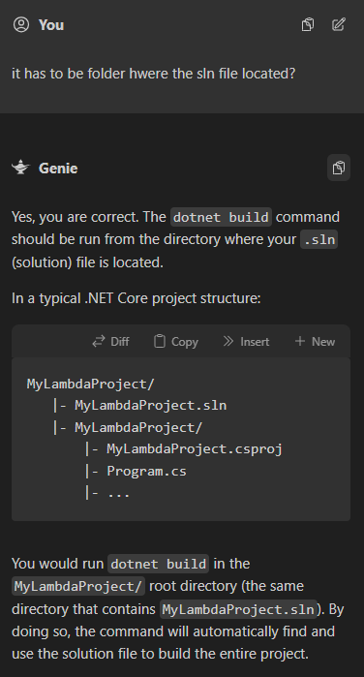

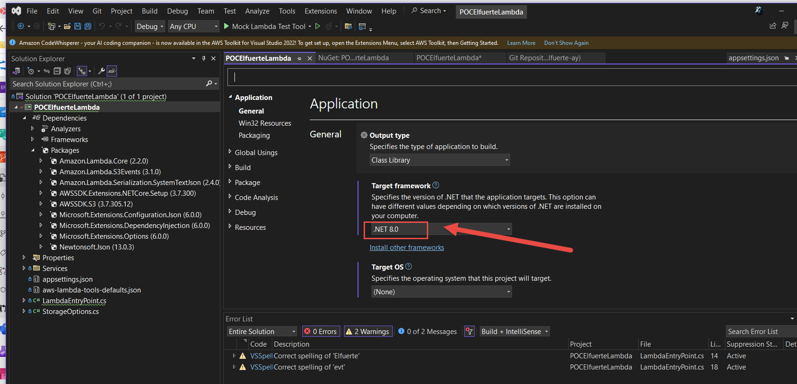



We install this extension. Looks like he uses it for building APIs to invoke.

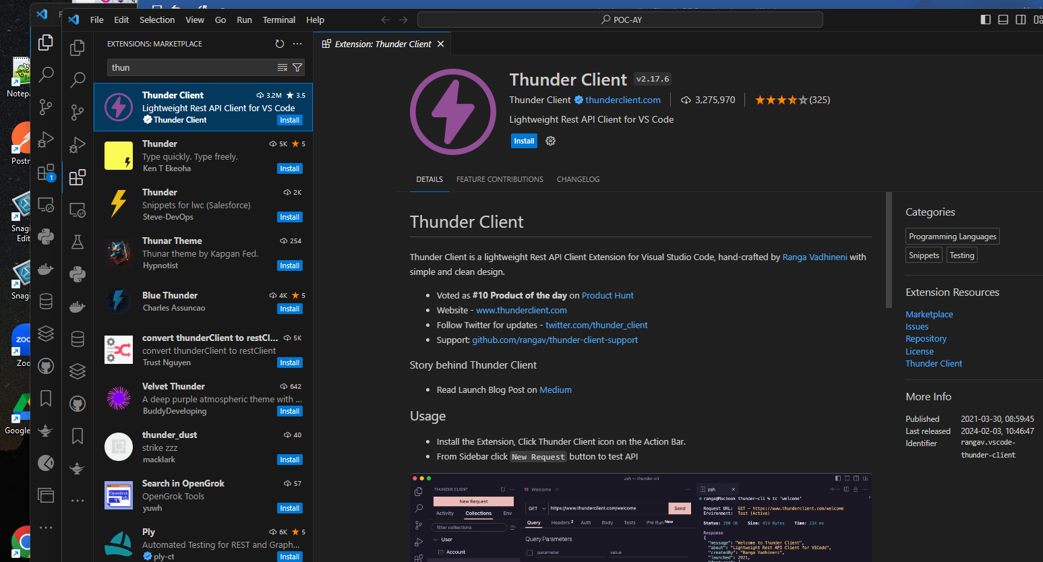

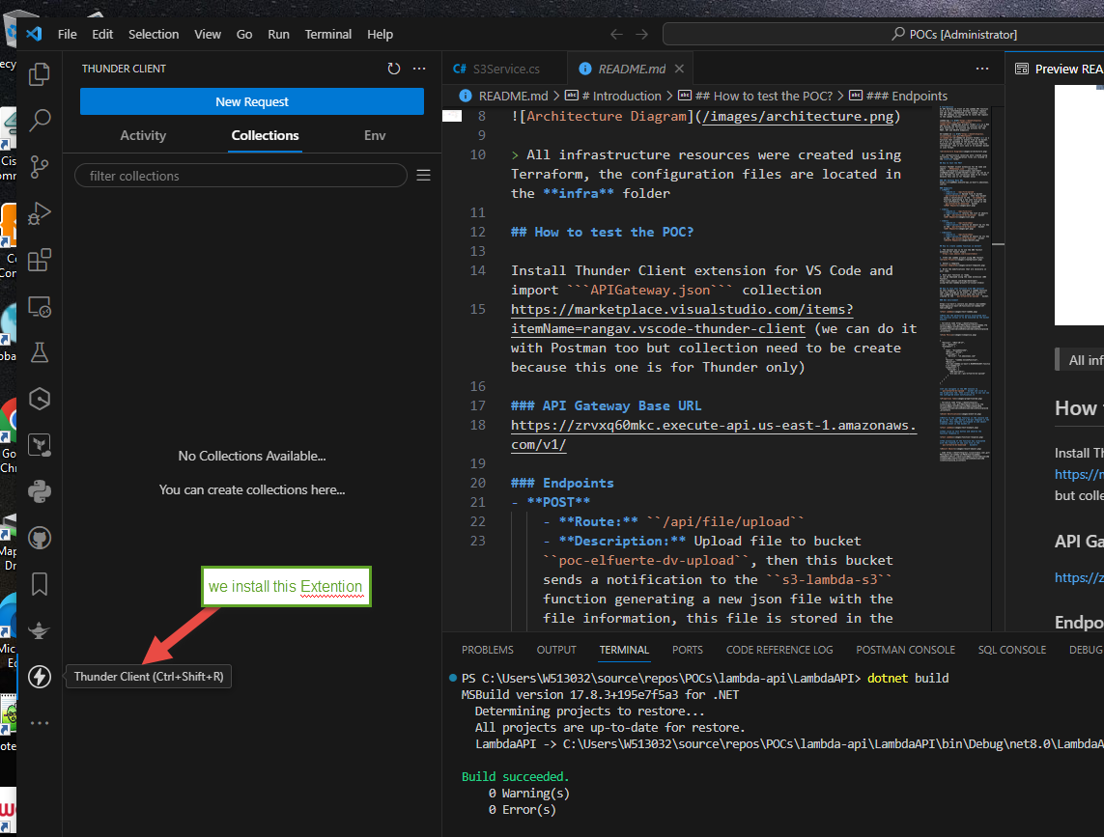

And import this collection:

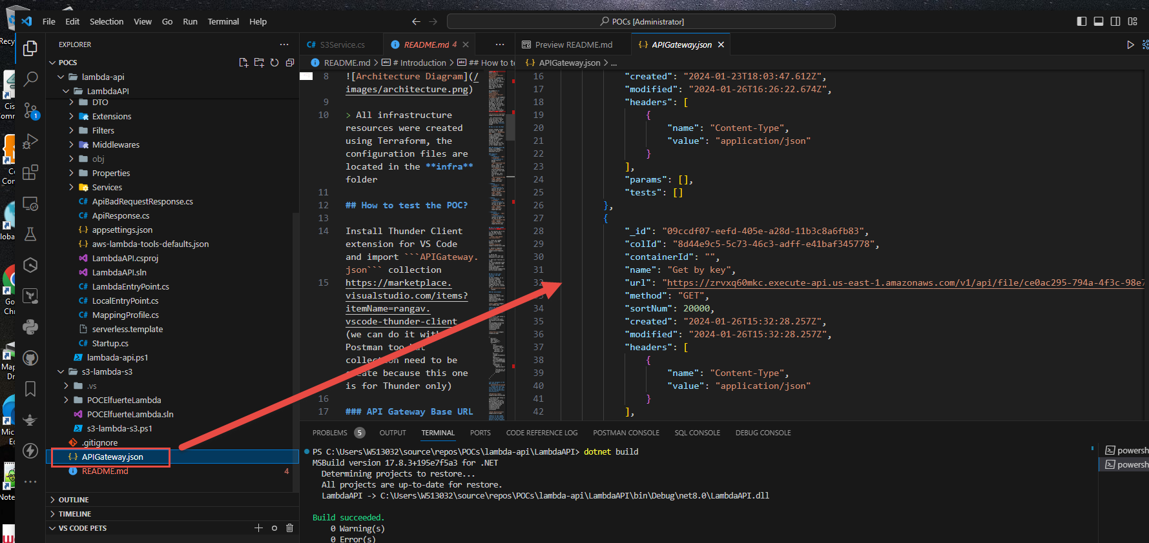

(Research on it, how he created this collection)

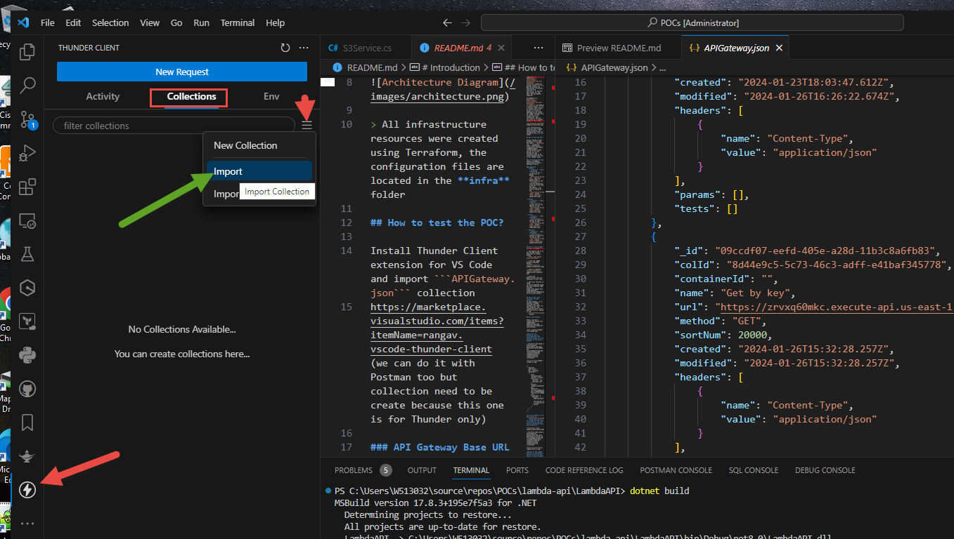

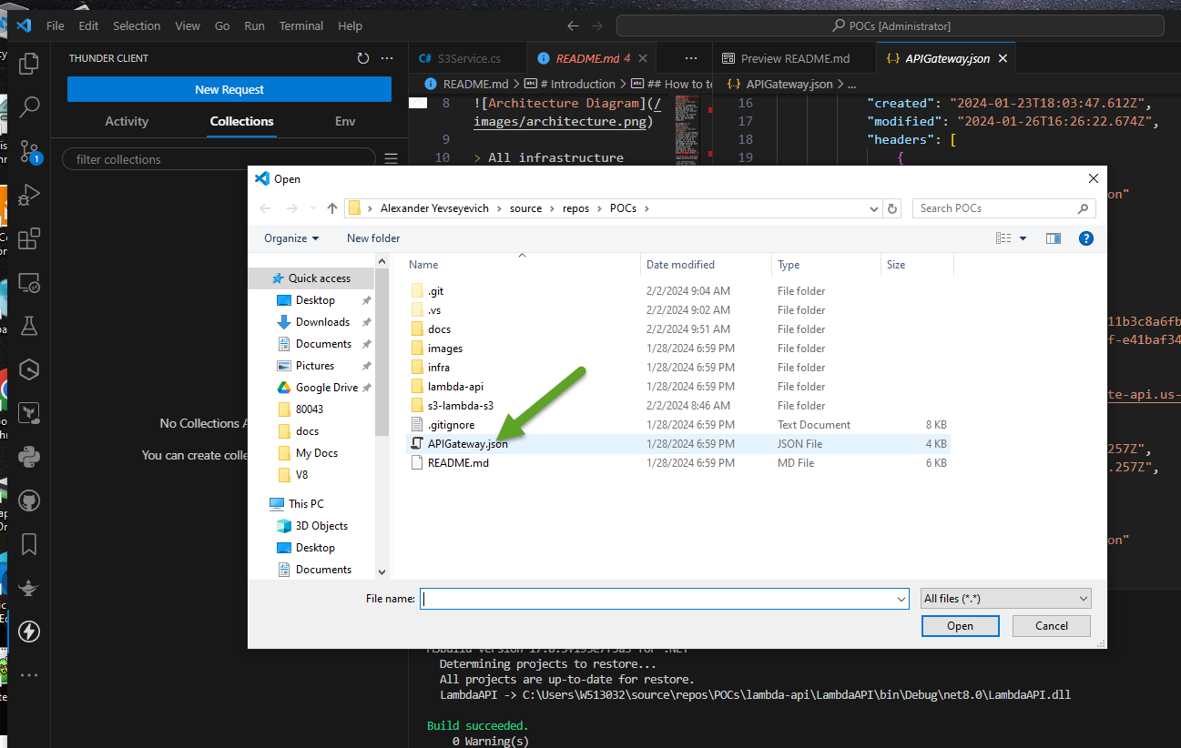

As the result we can see this

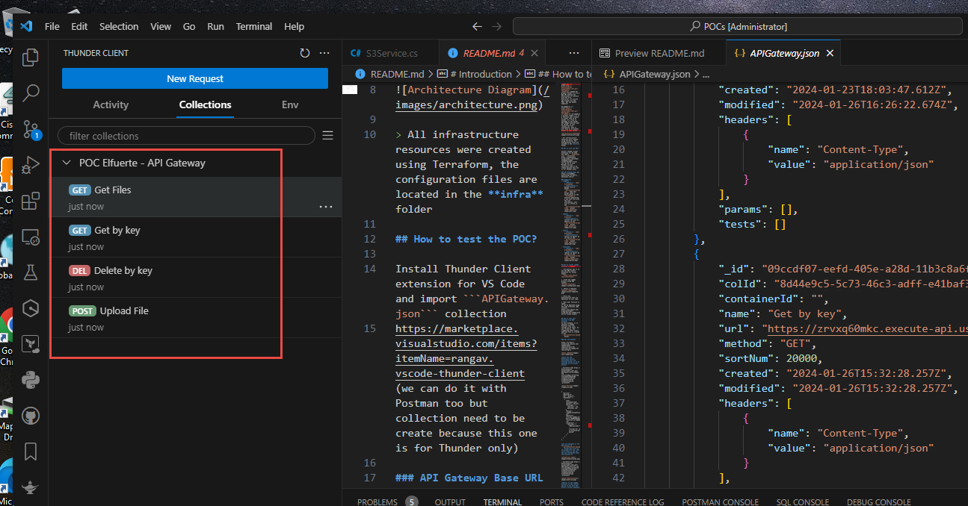

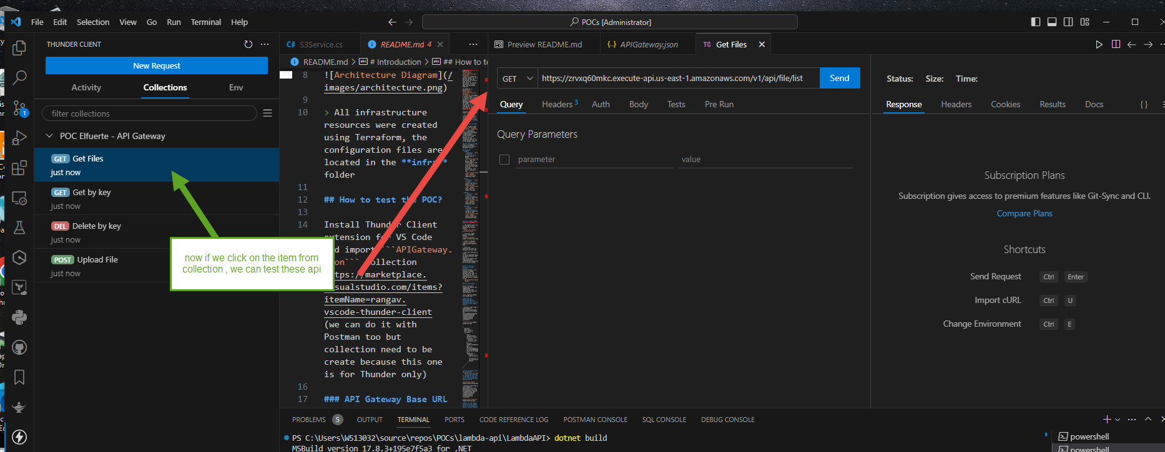

Now let us do Azure DevOps stuff

First we create a project to host our repository

(we have it in GitHub, but we can also host it in Azure)

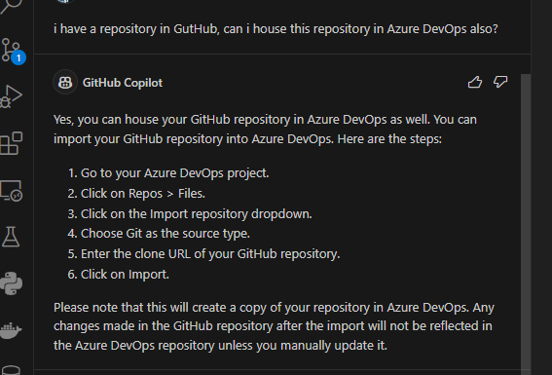

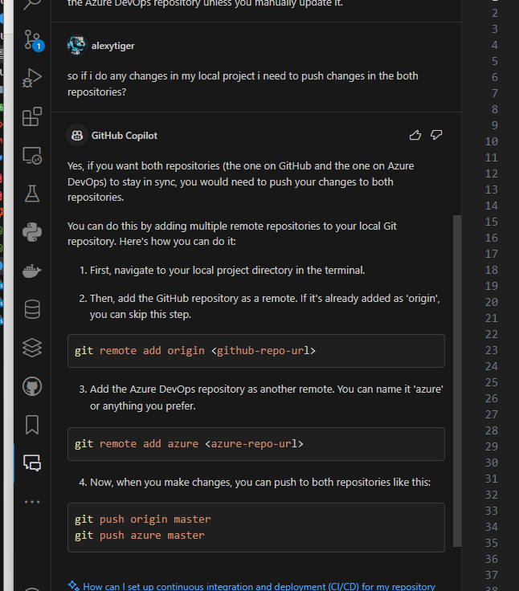

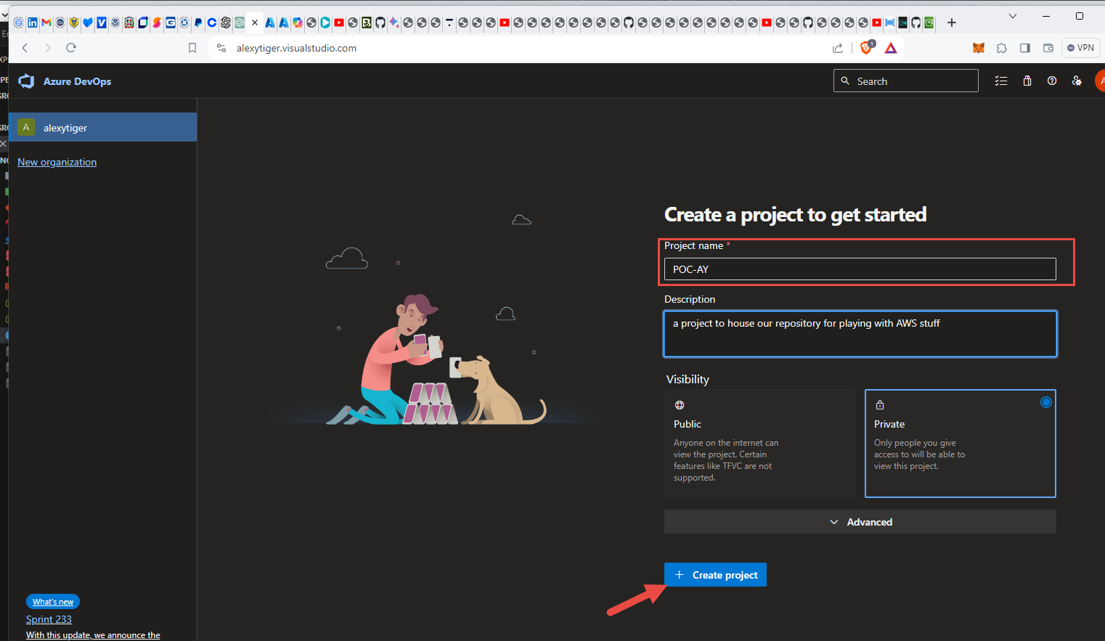

So we come here

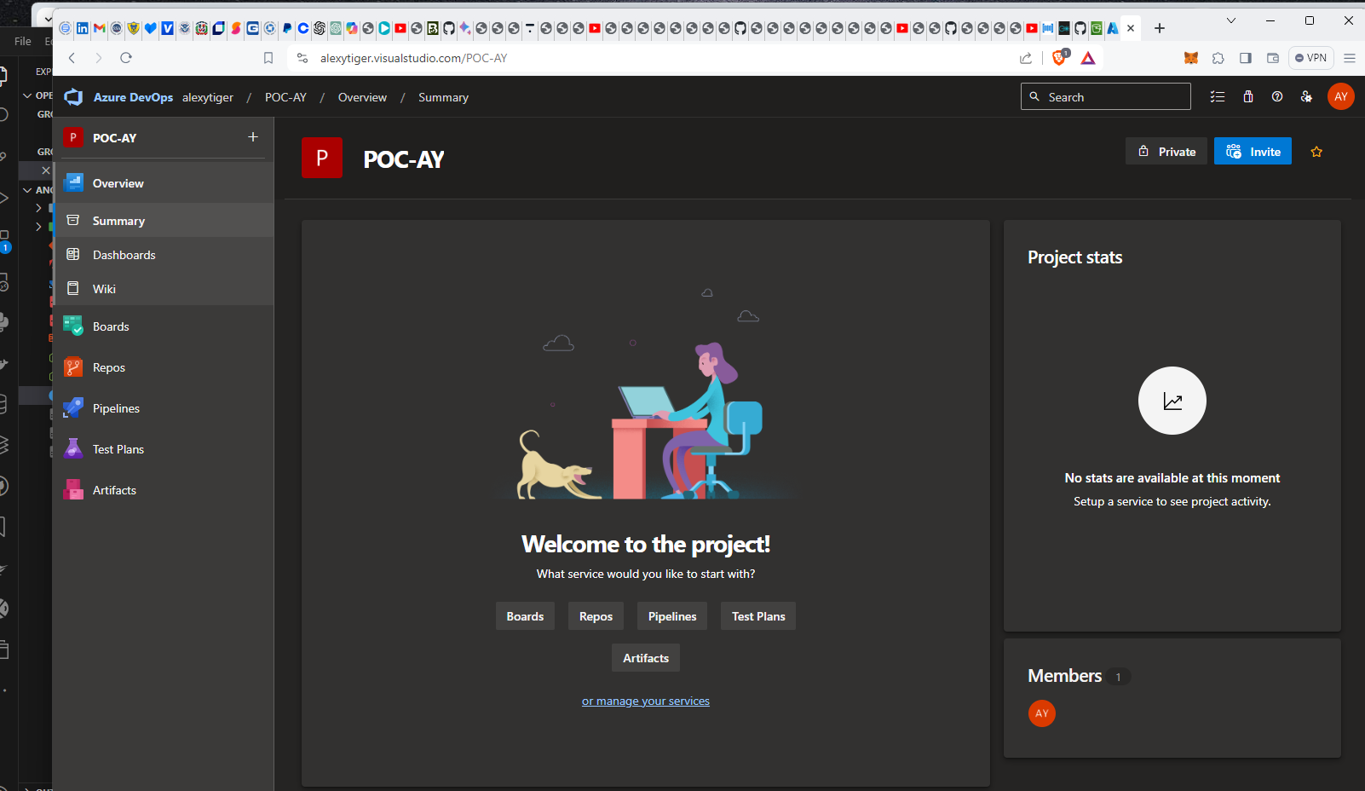

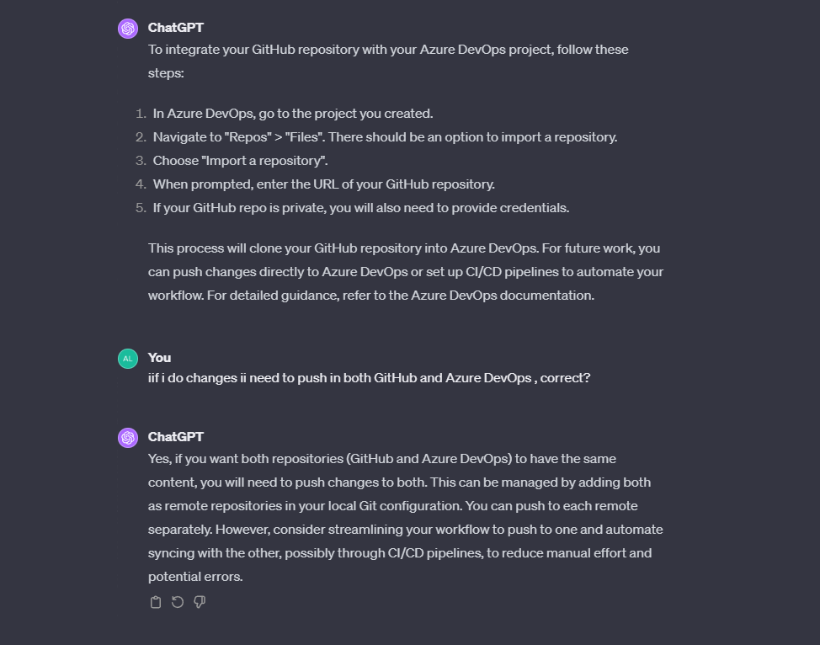

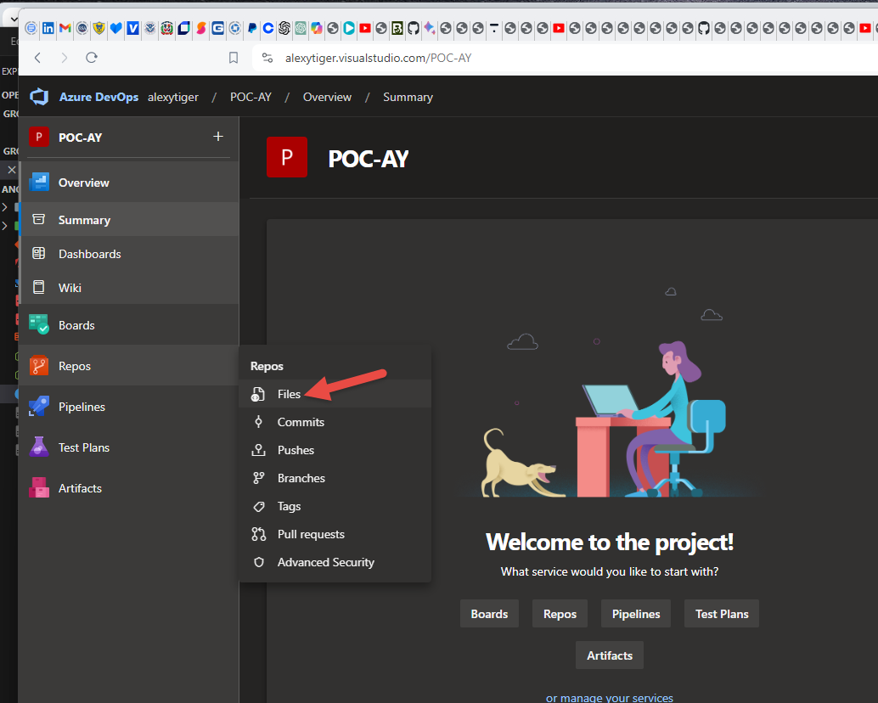

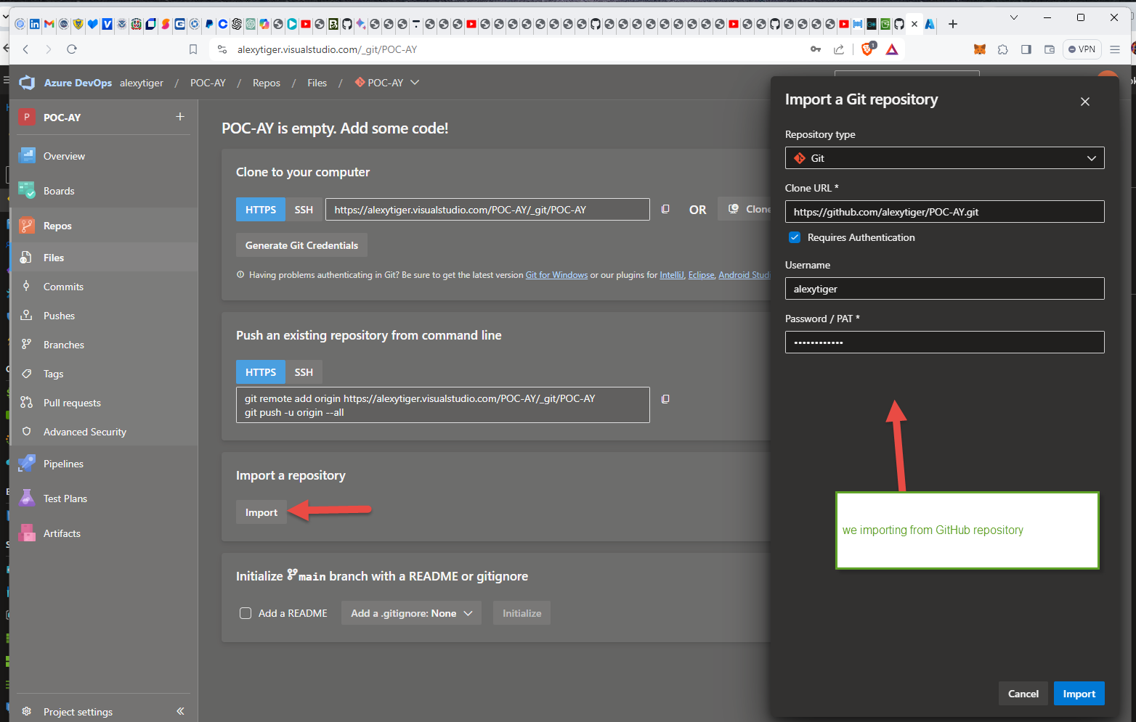

(Actually I had to make my GitHub repository public, because Azure DevOps was complaining ) as the result we have

<https://alexytiger.visualstudio.com/POC-AY/_git/POC-AY>

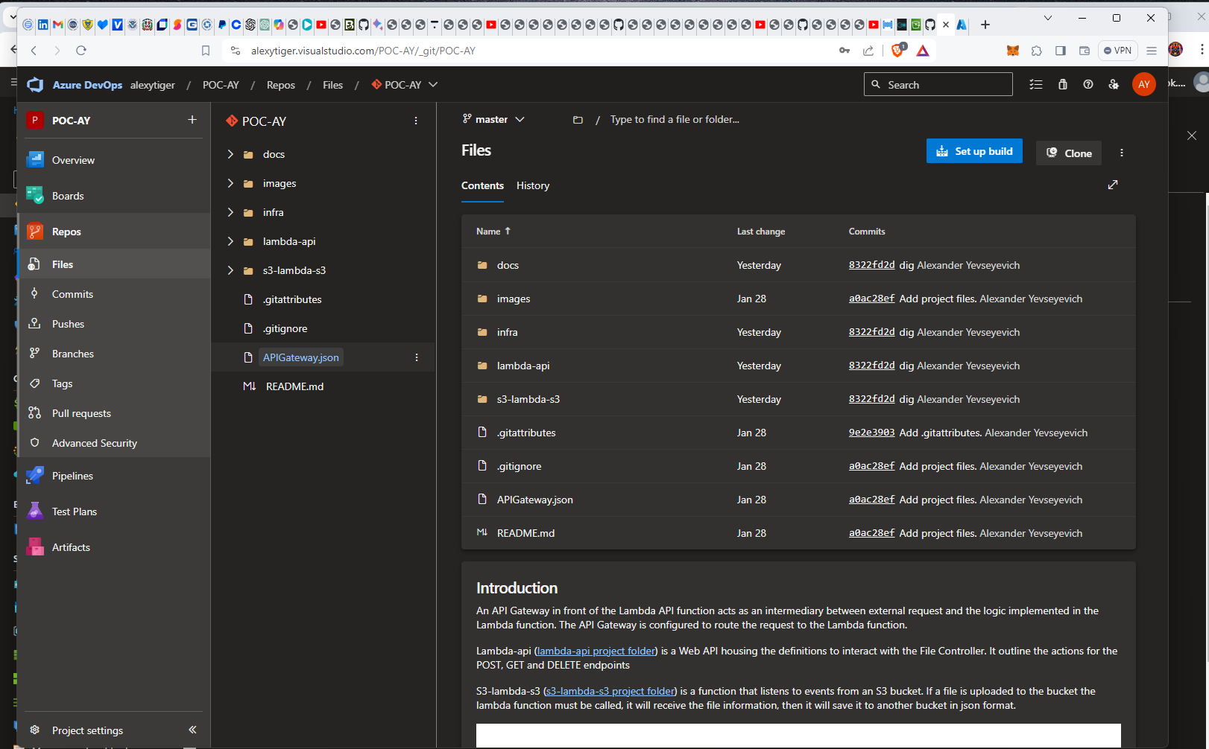

Let ‘s install this extension that allows to manage our repository in Azure DevOps

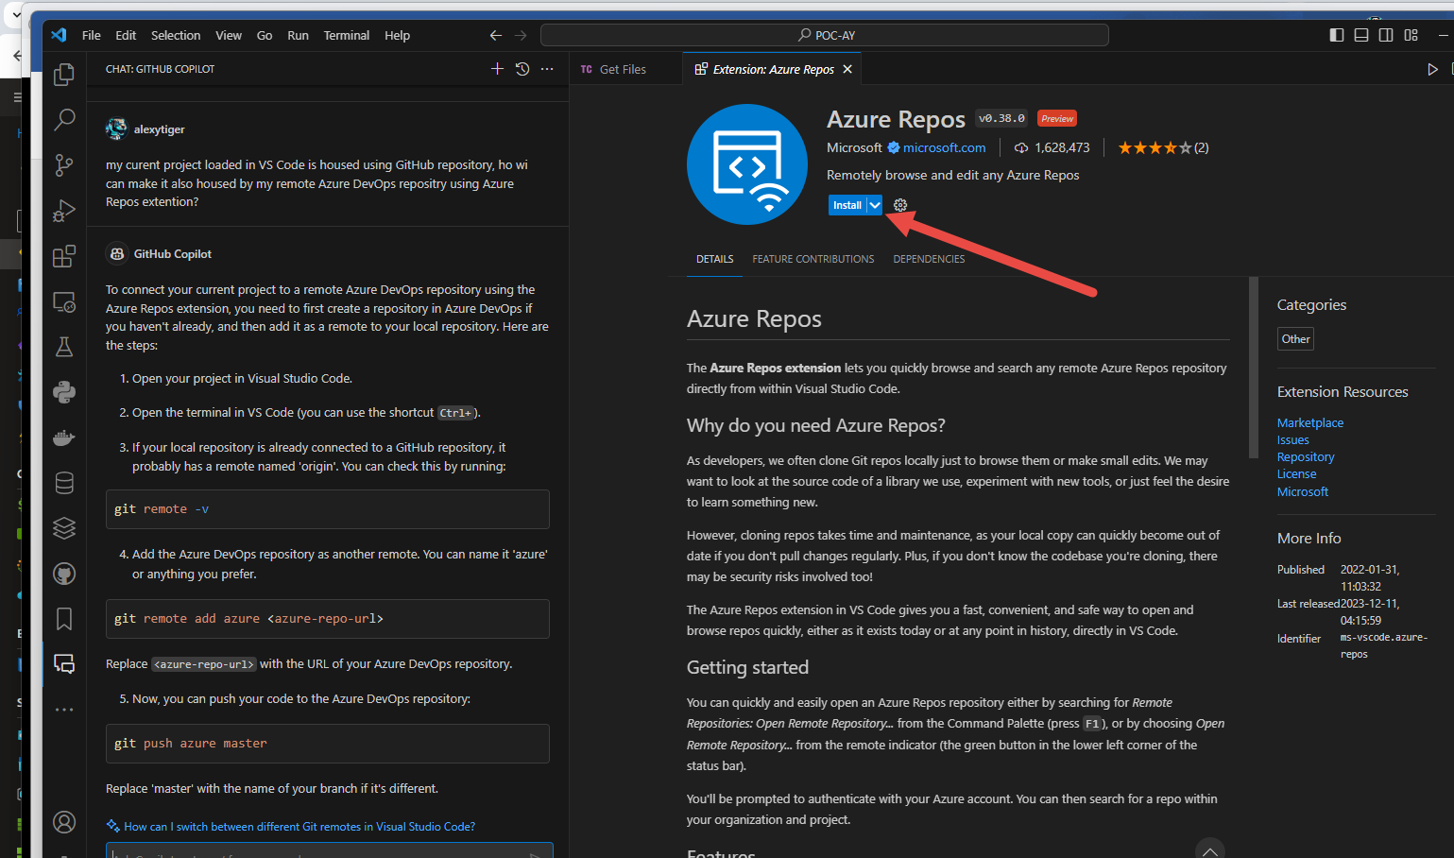

!!! Back off for now. Can not connect to my Azure Dev ops repository not from Visual Studio, not from VS Code.

